CSE 581

**Lab 9: Tables**

**1.**

CREATE TABLE Users (

NTID VARCHAR(20) PRIMARY KEY,

FirstName VARCHAR(50) NOT NULL,

MiddleInitial CHAR(1),

LastName VARCHAR(50) NOT NULL,

EmailAddress VARCHAR(100),

Password VARCHAR(50)

);

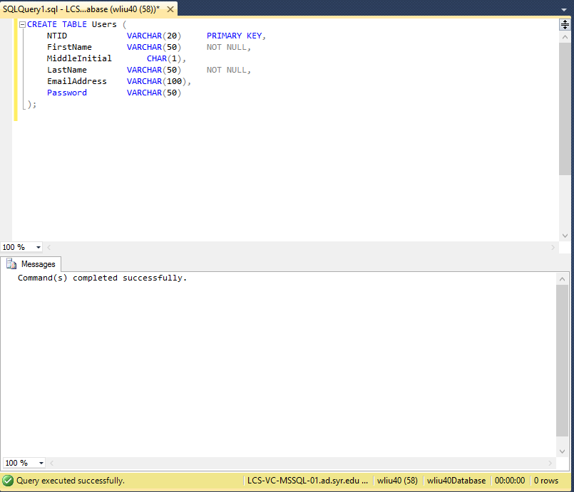

**2.**

CREATE TABLE Courses (

CourseId INTEGER PRIMARY KEY IDENTITY(1,1),

CourseCode VARCHAR(10) NOT NULL,

CourseTitle VARCHAR(50), NOT NULL,

Faculty VARCHAR(20) REFERENCES Users(NTID),

OpenSeats INTEGER NOT NULL

);

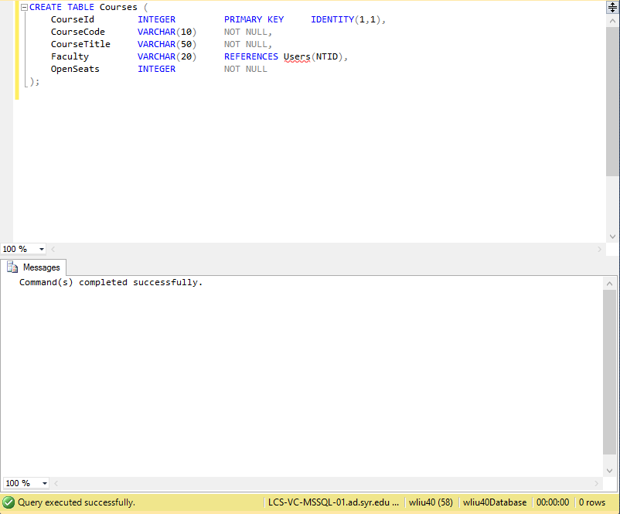

**3.**

CREATE TABLE LetterGrades (

LetterGradeId INTEGER PRIMARY KEY IDENTITY(1,1),

LetterGrade VARCHAR(2) NOT NULL,

Description VARCHAR(50)

);

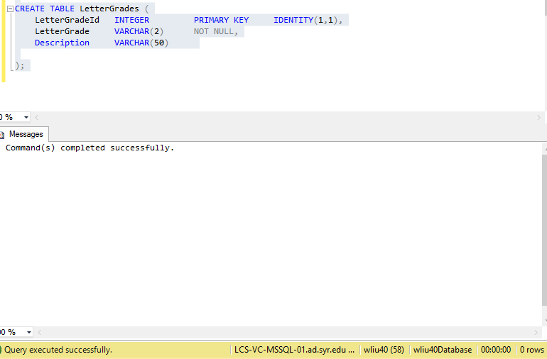

**4.**

CREATE TABLE CourseGrade (

GradingScaleId INTEGER PRIMARY KEY IDENTITY(1,1),

LetterGradeId INTEGER NOT NULL REFERENCES LetterGrades(LetterGradeId)

CourseId INTEGER NOT NULL REFERENCES Courses(CourseId)

GradeValue INTEGER NOT NULL CHECK(GradeValue >=0 )

);

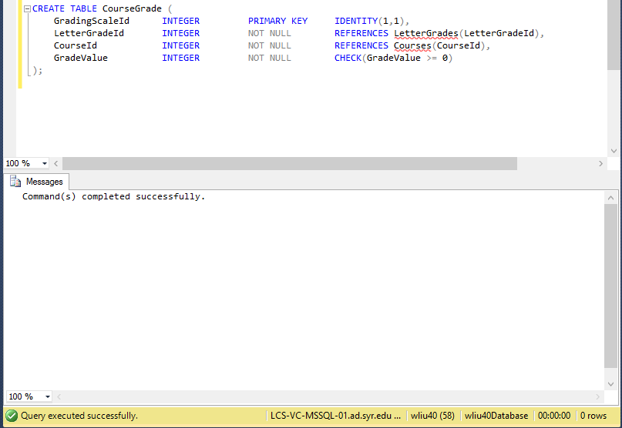

**5.**

CREATE TABLE CourseEnrollment (

EnrollmentId INTEGER PRIMARY KEY IDENTITY(1,1),

StudentId VARCHAR(20) NOT NULL REFERENCES Users(NTID),

CourseId INTEGER NOT NULL REFERENCES Courses(CourseId),

FinalGrade FLOAT CHECK(FinalGrade >= 0 AND FinalGrade <=100.0)

);

